Part 1: Start the Battleship game
Part 1 of this case study has you create a simple single-player Battleship game that allows the user to guess locations on the game board shown below. If the location is a hit, an X is placed on the game board. If not, an O is placed.
Prerequisite: chapters 1 through 6.
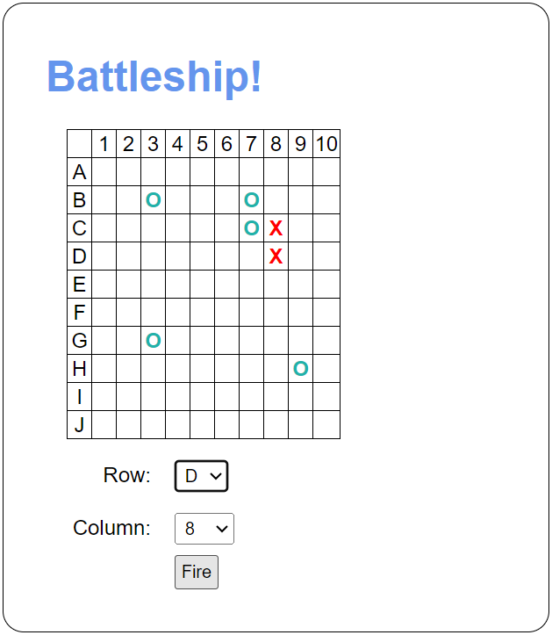

Specifications
- Use an array to represent each row. The rows should use an O to represent water and an X to represent part of a ship.
- There are five ships:
- Aircraft carrier: length 5
- Battleship: length 4
- Cruiser: length 3
- Submarine: length 3
- Destroyer: length 2.
- When the Fire button is clicked, the app should check that the user selected a row and a column. If so, the app should place a red X on the grid to indicate a hit or a light sea green O to indicate a miss.

